Spring Testing Exercises

Exercise 1: Basic Unit Test for a Service Method
Task: Write a unit test for a service method that adds two numbers.
Service:
@Service public class CalculatorService {
public int add(int a, int b) {
return a + b; } }
Test: Write code for this.

SOLUTION:

CalculatorService.java:
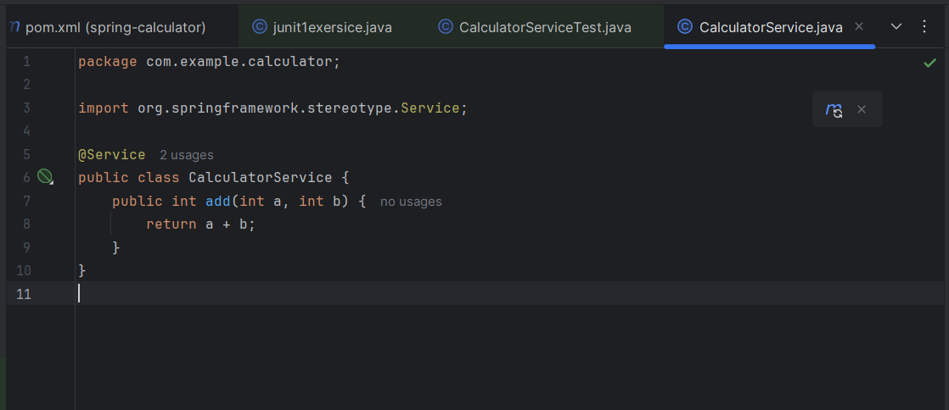

CalculatorServiceTest.java:
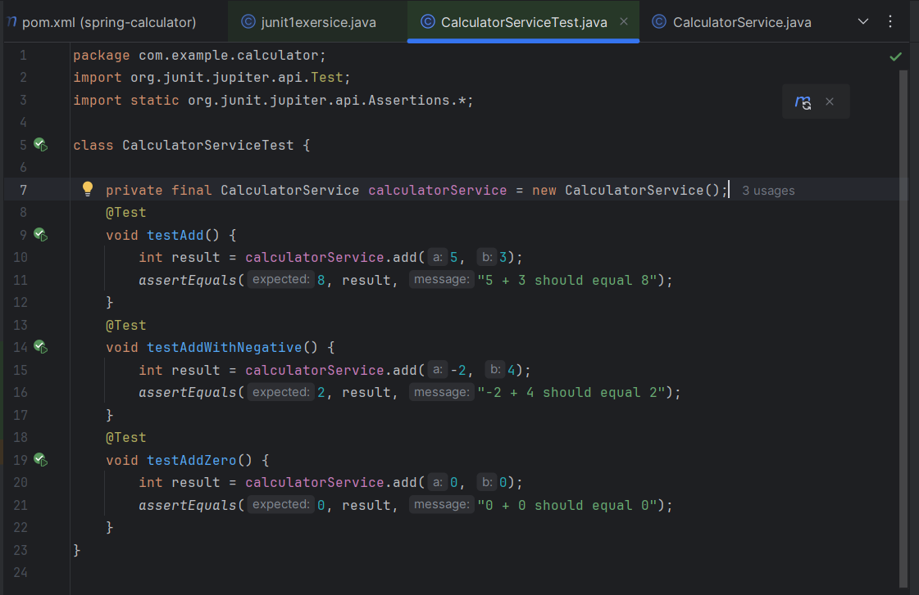
OUTPUT:
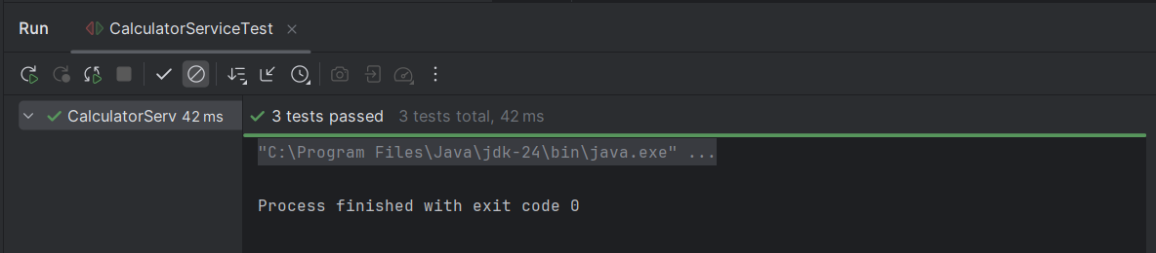

Exercise 2: Mocking a Repository in a Service Test
Task: Test a service that uses a repository to fetch data.
Entity:
@Entity
public class User {
@Id
private Long id;
private String name;
// getters and setters }
Repository:
public interface UserRepository extends JpaRepository {
}
Service:
@Service public class UserService {
@Autowired
private UserRepository userRepository;
public User getUserById(Long id) {
return userRepository.findById(id).orElse(null);
} }
Test:
Write code for this.

SOLUTION:
UerRepository.java:
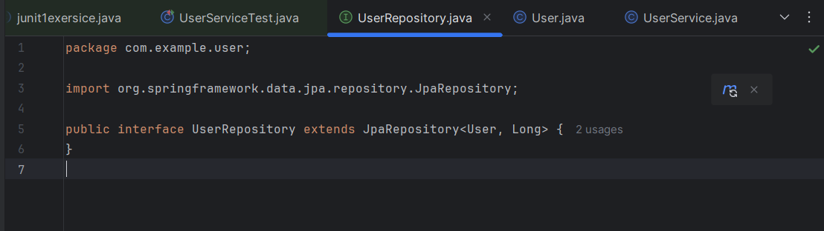

User.java:
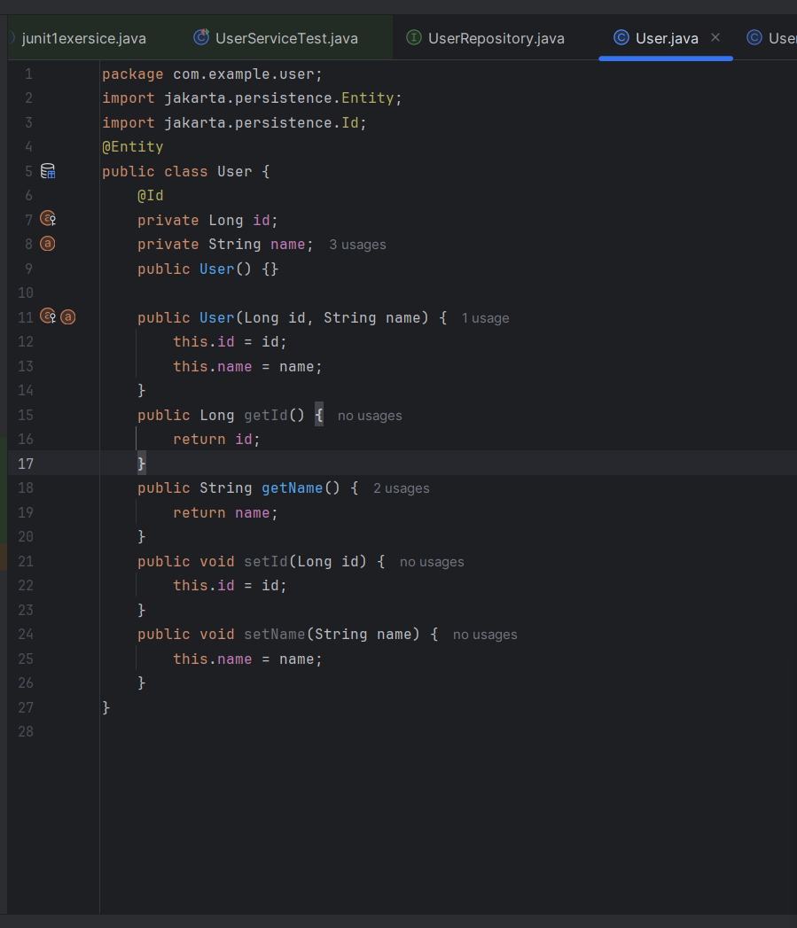

UserService.java:
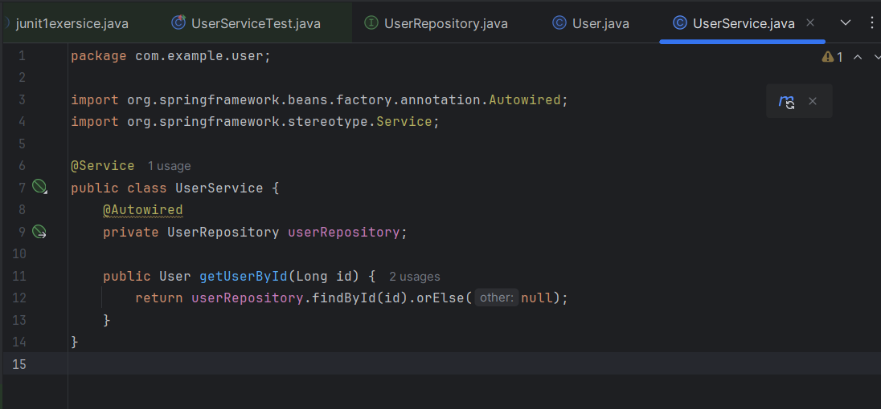
UserServiceTest.java:
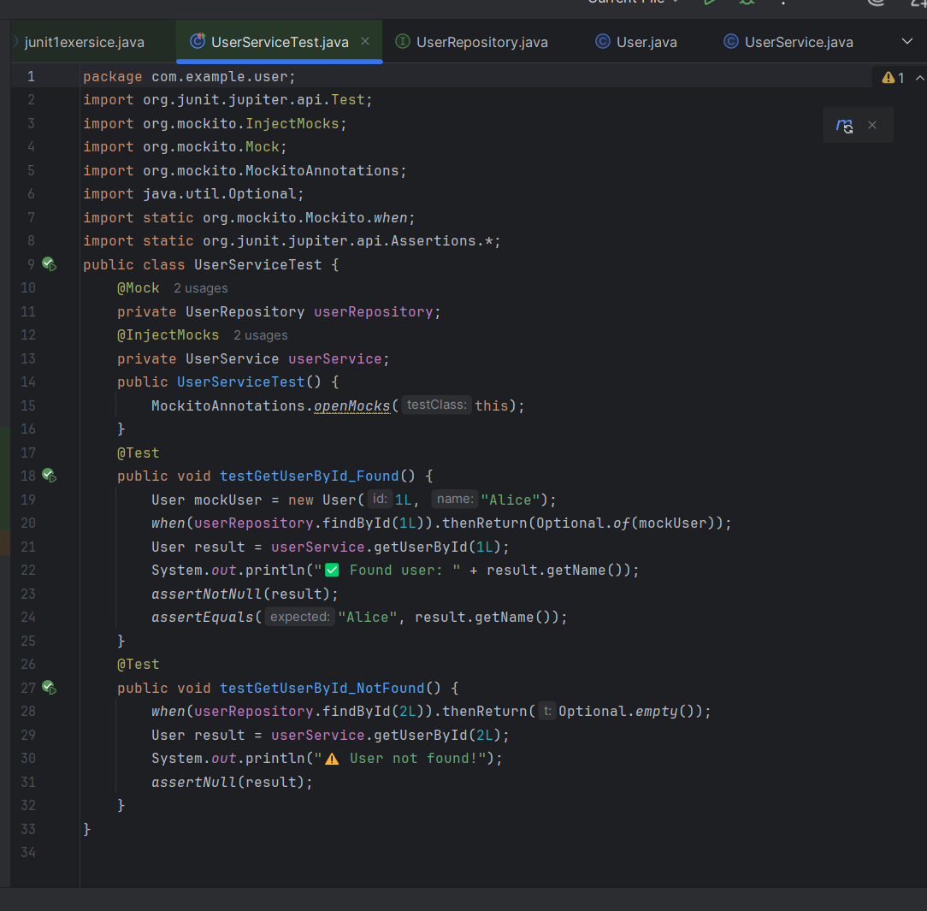
OUTPUT:
